Karin Metzgar

ASTE 546

HW 14

Part 1: Serial Code

A note about the HW14 PDF, in the screen shot you provided there is not a N-1 term in the final for loop which causes an error, it is correct in the code you provided but not in the screenshot. Just thought I’d point it out in case no one else did!

Part 2

Part 3:

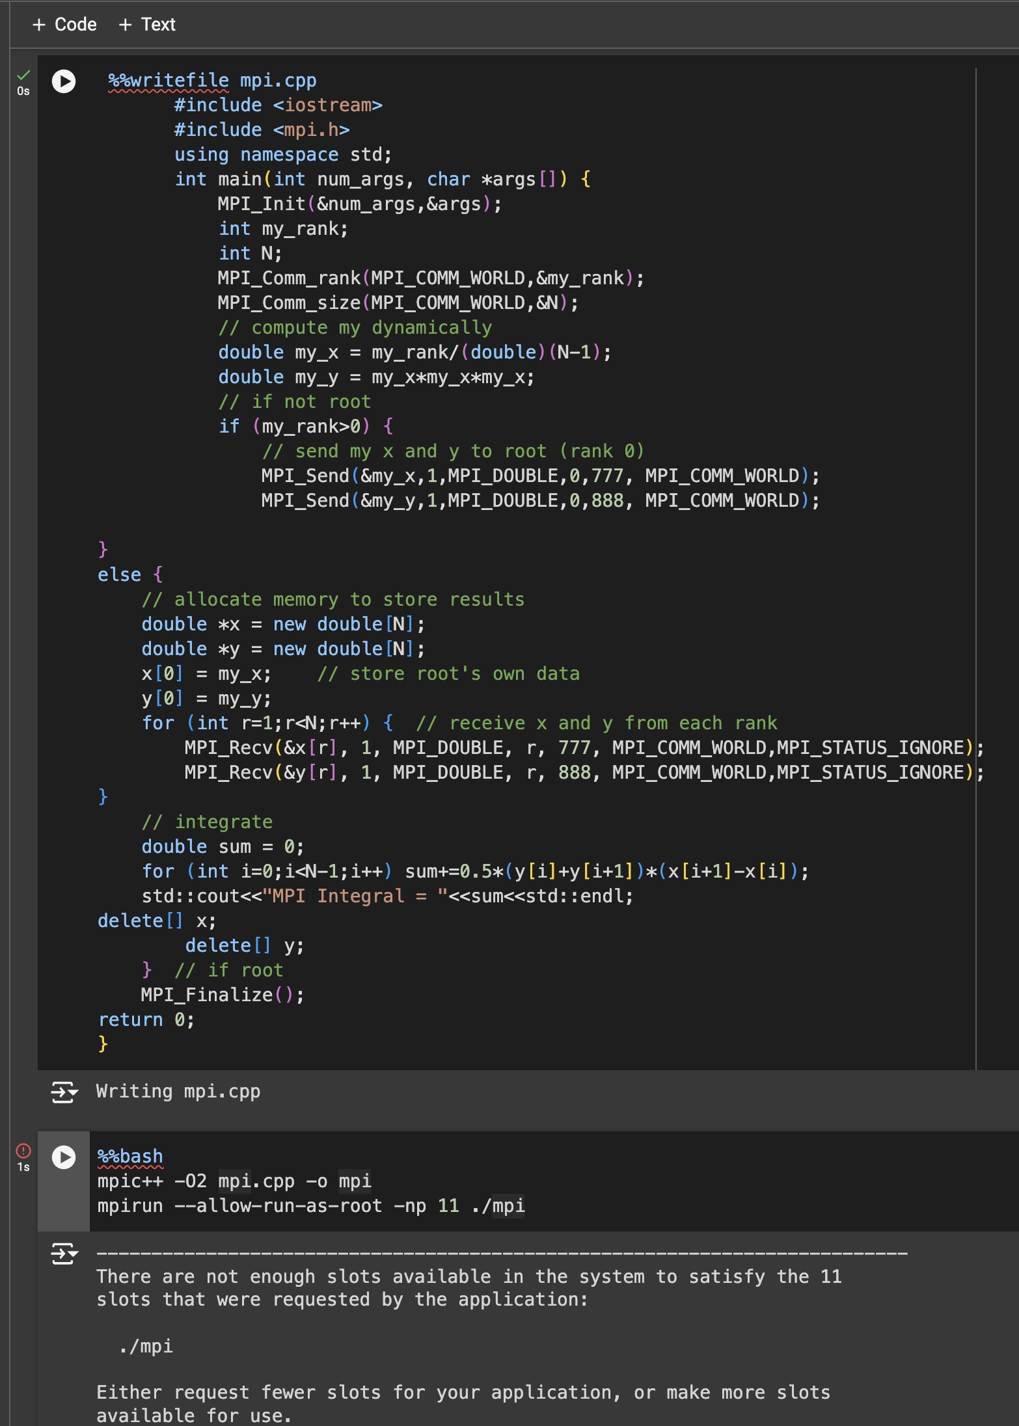

I got the “There are not enough slots” error if I used a number larger than 1, which resulted in sum = 0

I used the “oversubscribe” flag and was able to do more:

c) Both the send and receive functions go away

The loop that has all process (other than root) send their data to root is not necessary because the Gather function serves this purpose

The “else” code for the root was split up, the memory needs to be allocation before calling the gather function, then the gather function is called, then the rest of the block.

Part 4:

The code provided did not seem to work, and gave an answer of 0

I have T4 GPU selected

And I did need to remove the -arch=sm+37 because it generated an error

However the following code worked, with some help from the internet, the //launch kernel portion was added and that got the expected answer

/ Launch kernel

int blockSize = 256;

int numBlocks = (N + blockSize - 1) / blockSize; // Ceiling of N/blockSize

kernel<<<numBlocks, blockSize>>>(dev_x, dev_y, N);

// Synchronize the device

cudaDeviceSynchronize();

